Shot in the Heart of Australia
FACT SHEET 2
Image Hanging Guidance

For use by Australian Association of Street Photographers Incorporated members.

Important Notes
- All hanging is done by the exhibitors on hanging day, it is a VERY busy day; there are no gallery hanging staff.
- It is essential you arrive with an understanding of these notes. Your pictures must be ready to hang to the specifications outlined below.
- An update/reminder will be emailed to exhibitors before hanging day, listing the equipment necessary to make hanging day run as smoothly as possible.
Before
- Each image must be labelled on the back with your name, the image name and your contact details.
- Prints must be ready to go up on the wall, framed or mounted with the wire already in place as described in the VAS PDF mentioned above
On the day
- If you cannot attend on hanging day you will need to make alternative arrangements with a friend or family member. It must not be assumed the committee, or others will hang your images for you.
- Hanging day is a whirlwind of activity between 10am and 4pm
- Exhibitors are requested to arrive as early as possible and to help each other to hang and straighten efficiently.
- A committee member will direct you to your wall space.
- If you can hang around the committee would love help with putting the labels on the wall, wrangling hooks and wires, ladder holding and soothing nerves and general cheering up

What do I need?
- Your framed images, with labels on the back.
- Wires, Rail-hooks. (VAS will supply L-Hooks)

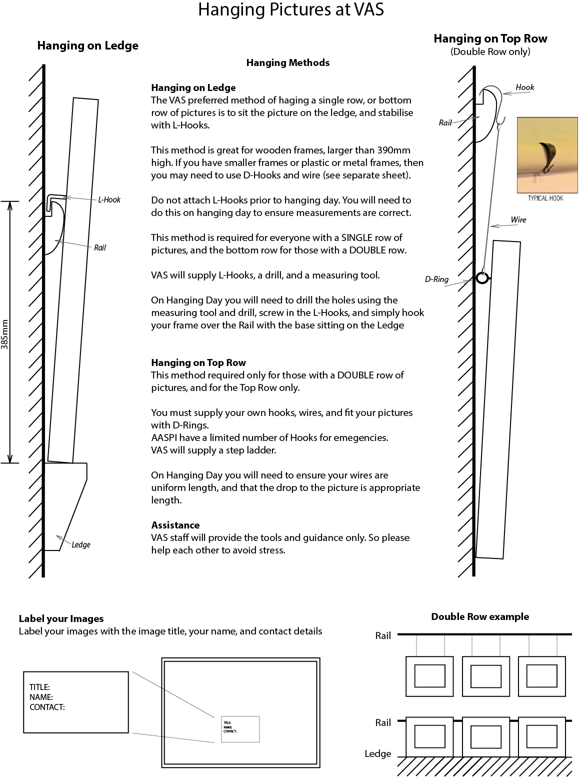

Alternative method - Wire
There are situations where you cannot use hooks and must use a wire. This is often the case if your frames are smaller than 390mm in height.
Use the following as guidance.
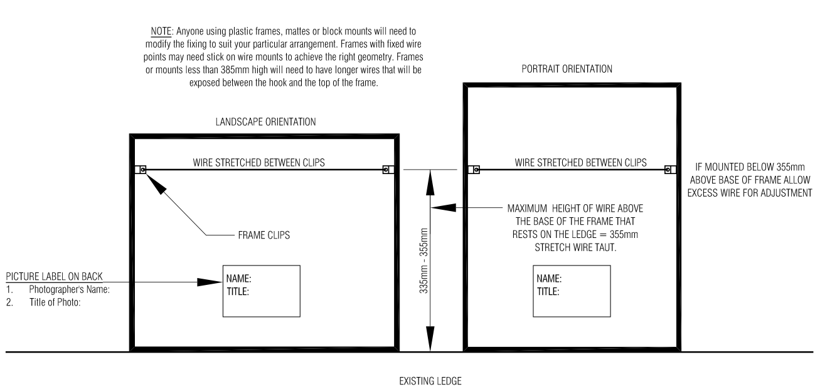

Wall Space examples
