Shot in the Heart of Australia
FACT SHEET 1

Submitting for Curation and Approval

Which images? How many? What Size? Printing? Mounting & Framing? Hanging?

Important dates
- Application Opening Date Now open
- Application Closing Date Sunday 15th May 2022
- Date for Final Image Acceptance Sunday 22nd May 2022
- Date for curation outcome Sunday 29th May 2022
- Last Date for Payment Sunday 5th June 2022 (for exhibition fees)
- Date for Receipt of Image Details Sunday 10th July 2022
- Hanging Day Wednesday 27th July,2022
- Exhibition Opening Date Thursday 28th July 2022
- Opening Event Date and Time Friday 29th July 2022 7pm-8:45pm
- Exhibition Closing Date Monday 8th August 2022
- Dismantling Day Tuesday 9th August 2022 10am-2pm.

Submitting for Curation

As you know Shot in the Heart of Australia is a curated exhibition and every image intended for exhibition MUST be submitted for approval.

- The committee reserves the right to reject any image which in the committee’s opinion does not meet Shot in the Heart of Australia submission guidelines or the standards of definition of Street Photography and photojournalism; if they do not meet any of the criteria specified in the Shot in the Heart of Australia Terms and Conditions.
- Please remember that late submissions may not be accepted and that the deadline for submissions for approval is the Date for Final Image Acceptance as defined above.
Submissions should be sent by email to events@aaspi.com.au. Please ensure the email provides FOR EACH IMAGE individually either:
- a URL to a downloadable image on a sharing website, eg, Dropbox or similar.
- an attached web suitable JPEG (1024px on the longest side and 72 dpi).
***Please do NOT send a link to an account, page or album. We need an image for each INDIVIDUAL print you wish considered ***
***PLEASE NOTE: If you wish to supply an image with a watermark (optional) only watermarks in the bottom corner of the image will be accepted.

Which Images?
As stated in the Shot in the Heart of Australia Terms and Conditions only images meeting submission guidelines and pre- approved by the Shot in the Heart of Australia committee may be hung in the exhibition.

How many?
- As many framed as you can fit into your allocated 2.85m width of wall space.
- There is no set a minimum number of prints per exhibitor.
- The practical maximum is 10, which involves hanging in two rows (double hanging).
- Most exhibitors single hang 5 images with 100mm between each work.

What Size?
- Images should be no smaller than A4, then framed with matt.
- Standard size is no larger than18 x12 inch or 20.3 x 30.5cm print, although you may use larger prints as long as they fit within your allocated space. Remember that framing will add to this size.
- Remember to consider both your frame size and your image size.

Printing?
- If you do not have a preferred printer, many exhibitors recommend the quality and price of online printers Photo Enlargements. Their B&W processing is exceptional and pricing is great value, especially if you order 20+ images.
- Another recommendation for combined printing and framing is the cost effective and user friendly Frameshop.com.au
- Shot in the Heart of Australia has no affiliation with printers or framers and each recommendation is made without responsibility for final results.

Mounting & Framing?
- All prints should be framed with a matt. This provides a level of consistency across the exhibition.
- Many exhibitors use black IKEA Ribba Frame which includes a pre-cut mat for a 16x12inch or 30x40cm print. They are a good size, relatively inexpensive and look smart. You can use their pre cut mat or have one cut to the frame size to match your image.
- Frames Now at various locations have a while you wait service.
- If you choose to use the IKEA mats, or another pre-cut mat, it is important to measure the mat window exactly BEFORE ordering your prints to ensure correct sizing for your image display.
- Custom frames or very economical frames at discount shops may also be used but it is advised to check less expensive frames for tight mitre corners, and adaptability for hanging options.

Hanging?

It is important to indicate if you wish to double hang or single hang as soon as possible, to assist with the allocation of space.

Provision for this is on the application form.

Single
- Typical single row hanging is on a formal set picture ledge 120cm from the floor.
- The weight of the frame is taken on the ledge, with a picture rail to stop the frame falling forward. (Reference images and video can be found on the Shot in the Heart of Australia exhibition page of the AASPI website.)
- Full details for preparing hanging wires are included on the SITHOA Resources pages on the AASPI website, with exact specifications for the Victorian Artists Society (VAS) galleries.

Double
- Double row hanging is possible, but not easy. (Reference images and layout examples can be found on the SITHOA Resources pages on the AASPI website)
- It is advised that you arrange with a member of the committee to meet at VAS to discuss the options and procedures for double hanging. Please do not visit VAS without advising the committee, our arrangement with them does not include individual assistance by VAS staff, and Shot in the Heart of Australia members understand the practicalities of double hanging fully.
- The lower row hanging formal "ledge" on which the pictures rest is 1200mm above the floor, and the picture rail that you hook the wire to (or hook the "L" shaped bracket over) is 384mm above this ledge.
- The high picture rail is not really a formal picture rail but has been used to hang from in the past. The higher "rail" (looks more like a cornice) is 1595-1620mm higher than the ledge.
- The VAS staff will provide a ladder, but you must provide everything else (wires, nails.... etc) to complete the secure hanging of the second row.
- The normal means of display is to rest the picture on the lower ledge (taking the weight) and then hooking over the picture rail 384mm above the ledge to stop it tipping forward. This method works well and enables easy adjustment of image location on short notice.

The examples below show some single row hanging configuration. Refer also to “SITHOA Fact Sheet 2 – Exhibition” for more information on hanging prints.

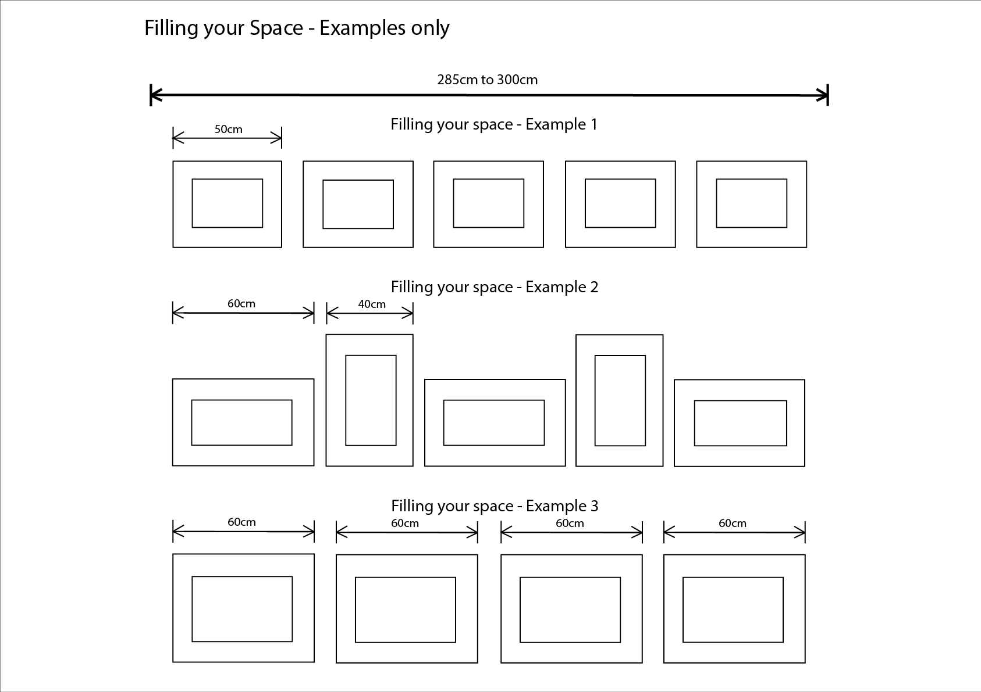

If you have any questions please check the resources tab documents on the website and T&Cs, if still not answered, let us know through the contact page on our AASPI website.

If you have any suggestions for information to add to the fact sheet, please let us know through the comment contact page on the AASPI website.

